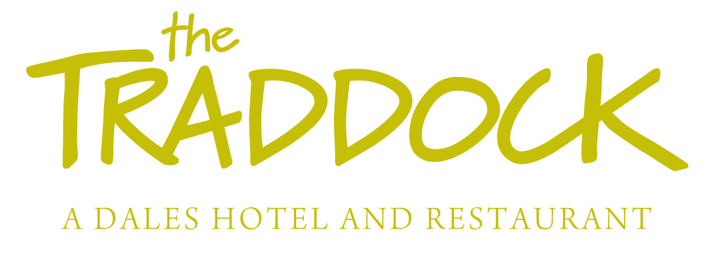

Dog Policy

We welcome well behaved dogs at The Traddock, at a charge of £10.00 per dog per night. We would kindly ask that owners and their pets show consideration and respect for our hotel and other guests.

- We allow a maximum of 2 dogs in our bedrooms.

- We would ask that owners control their dogs at all times.

- Dogs are welcome in our bedrooms, but should not be left unattended in the rooms for long periods.

- Dogs are not permitted on the beds or any other furniture.

- Owners must bring their own pet bedding.

- We do not allow dogs in the restaurant or breakfast room.

- Dogs are allowed in the lounges and bar as long as they are kept on a lead at all times and do not disturb other guests.

- Dogs are welcome to enjoy our gardens; owners must clear up after them. There is a dog waste bin at the far end of the car park, at the top of the steps down to the lower lawn. We can provide doggie scoop bags on request.

- Please make sure your dog is clean before coming into the hotel. There is a hose in the garden that you can use to clean your dog, and we can provide towels if required.

- If there is damage or excessive mess caused by dogs a charge of up to £50.00 will be added to the owner’s bill or charged to your card if you have checked out.

Thank you
The Traddock team

